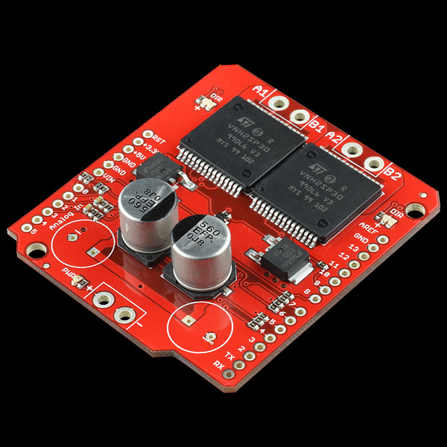

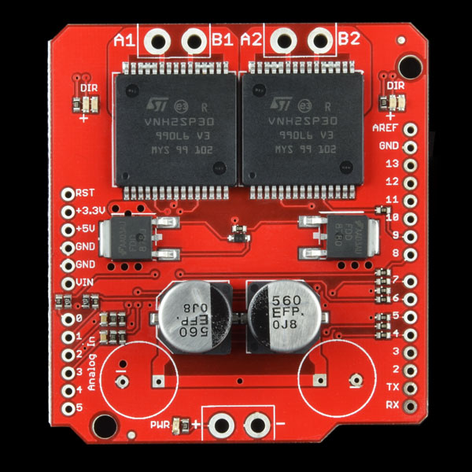

**SparkFun Monster Moto Shield**

DEV-10182 [RoHS](https://www.sparkfun.com/static/rohs/)   
[1](https://www.sparkfun.com/products/10182#reviews)

**Description:** This is essentially a ramped up version of our Ardumoto motor driver shield. For this SparkFun Monster Moto Shield we’ve replaced the L298 H-bridge with a pair of VNH2SP30 full-bridge motor drivers. We’ve also beefed up the support circuitry so this board is capable of driving a pair of high-current motors! The VIN and motor out are pitched for our 5mm screw terminals (not included), making it easy to connect larger gauge wires.

**Note:** When using this board in extreme high-demand applications it may be necessary to improve thermal performance with a heat-sink or fan and to solder the wires directly to the board instead of using a screw terminal (in addition to the myriad other complications present in a high-current system) However, when using the board at currents up to 6A the chips will barely become noticeably warm.

**Features:**

* Voltage max: 16V
* Maximum current rating: 30 A
* Practical Continuous Current: 14 A
* Current sensing available to Arduino analog pin
* MOSFET on-resistance: 19 mΩ (per leg)
* Maximum PWM frequency: 20 kHz
* Thermal Shutdown
* Undervoltage and Overvoltage shutdown

**Documents:**

* [Schematic](http://cdn.sparkfun.com/datasheets/Dev/Arduino/Shields/MonsterMoto-Shield-v12.pdf)
* [Eagle Files](http://cdn.sparkfun.com/datasheets/Dev/Arduino/Shields/MonsterMoto-Shield-v12.zip)
* [Datasheet](http://cdn.sparkfun.com/datasheets/Dev/Arduino/Shields/10832.pdf) (VNH2SP30)
* [Example Code](http://cdn.sparkfun.com/datasheets/Dev/Arduino/Shields/MonsterMoto_Shield_Example.pde)
* [GitHub](https://github.com/sparkfun/Monster_Moto_Shield/tree/Hv12Fv10) (Design Files & Example Code)